Objective:
In this lab, we learned about:
- Computer memory and variables
- Pointers
- How to declare pointers
- Referencing operator (&)
- Dereferencing operator (*)

Introduction:
In C++, every variable is stored in computer memory, and each memory location has an address. A pointer is a special variable that stores the address of another variable instead of storing a value directly.
Pointers help us work with memory directly and are very useful in programming.

Theory:
1. Computer Memory and Variables
When we create a variable, the computer stores it in memory. Each variable has:
- A value
- A memory address
2. Pointers
A pointer is a variable that stores the address of another variable.
Example:
If x = 10, then a pointer can store the address of x.
3. Pointer Declaration
We declare a pointer using *.
Example:
int *ptr;
This means ptr is a pointer that can store the address of an integer.
4. Referencing Operator (&)
The & operator is used to get the address of a variable.
Example:
int x = 5;
int *ptr = &x;
5. Dereferencing Operator (*)
The * operator is used to get the value stored at the address.
Example:
cout << *ptr;
This will print the value of x.

Example Program:
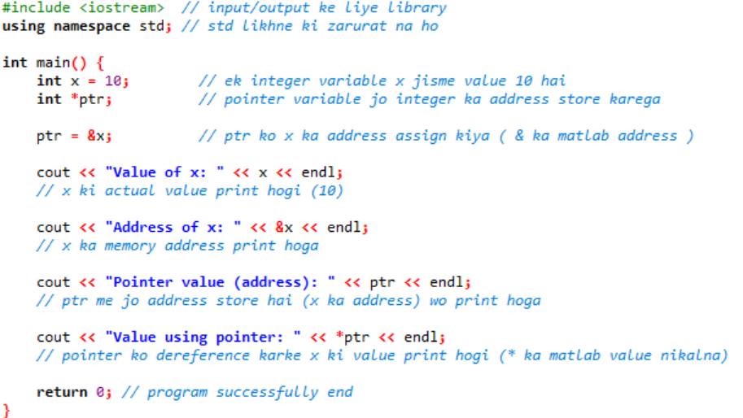

Output:
Value of x: 10
Address of x: (some memory address)
Pointer value (address): (same address)
Value using pointer: 10

Conclusion:
In this lab, we learned that:
- Variables are stored in memory with addresses
- Pointers store addresses of variables
- & is used to get address
- * is used to get value from address
Pointers make programming more powerful and efficient.

Lab 12 Tasks:
1. Pointer Declaration and Initialization
• Declare an integer variable called num and initialize it with a value of your choice.
• Declare a pointer variable called ptr of type integer.
• Initialize the pointer variable to point to the address of the num variable.
• Display the value of num and the value pointed to by ptr using the de reference
operator.

Code:
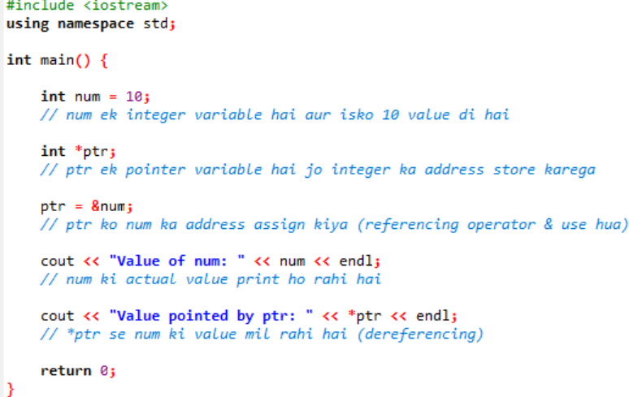
2. Pointer Arithmetic
o Declare an integer array called numbers with some values of your choice.
o Declare a pointer variable called ptr of type integer and initialize it to point to the first
element of the num array.
o Use pointer arithmetic to access and display the elements of the array using the pointer.
Code:
